
Comsats University Islamabad
(Vehari Campus)

Submitted by: Naveed Abbas

Submitted to: Ma’am Yasmeen Jana

Registration No: FA22-BSE-109

Subject: Advanced web technologies

Topic: Lab Final

First page:
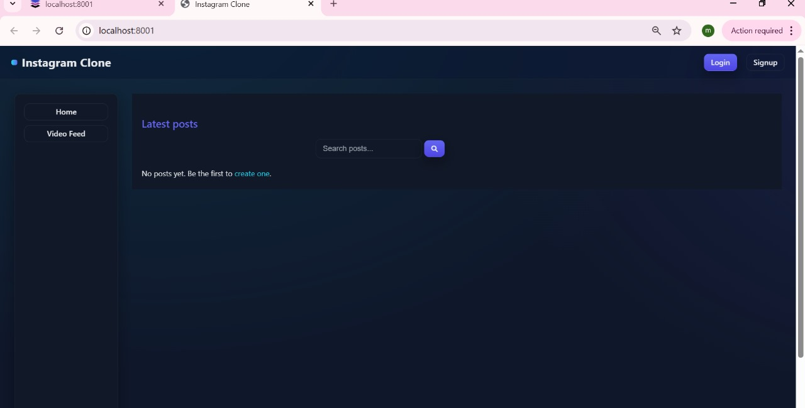

Signup:
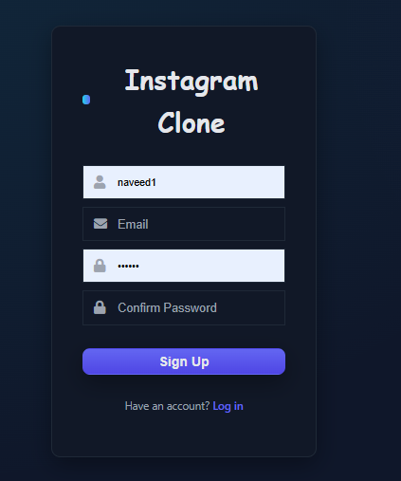
login:
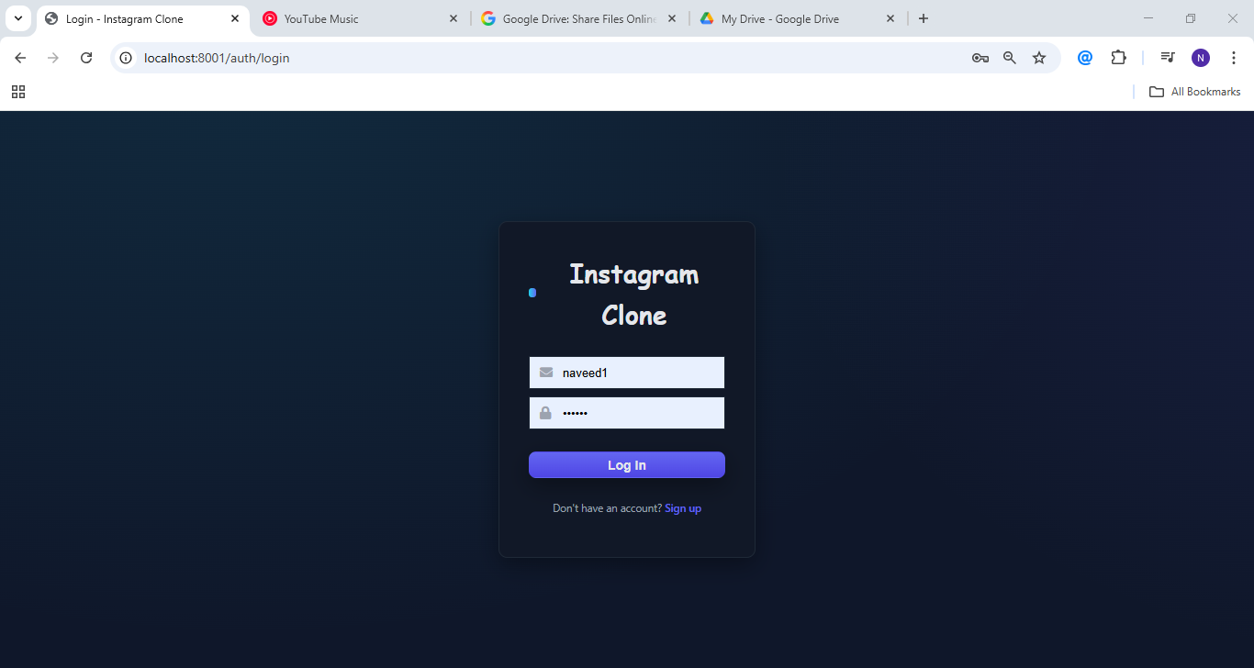

Home:
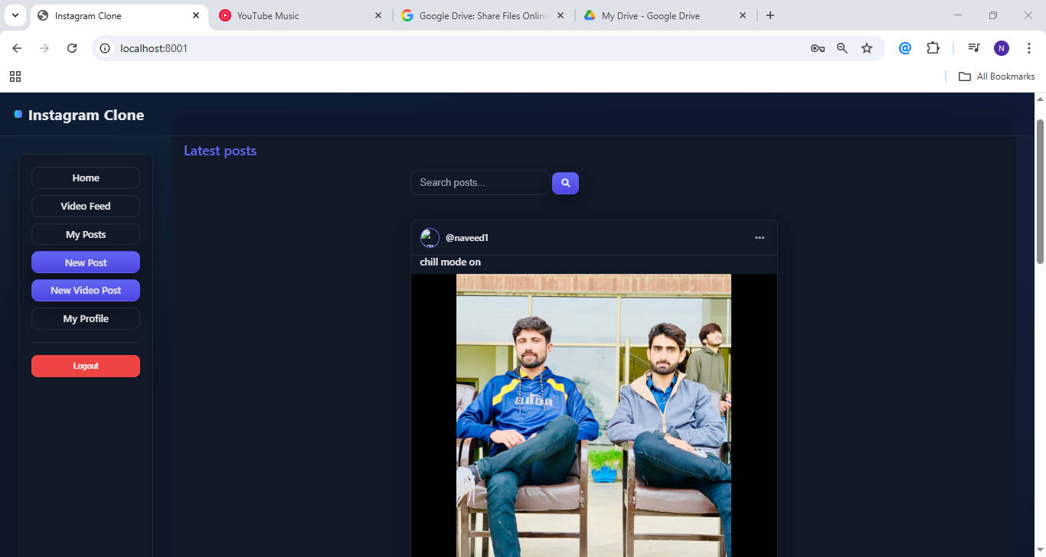

Posts:
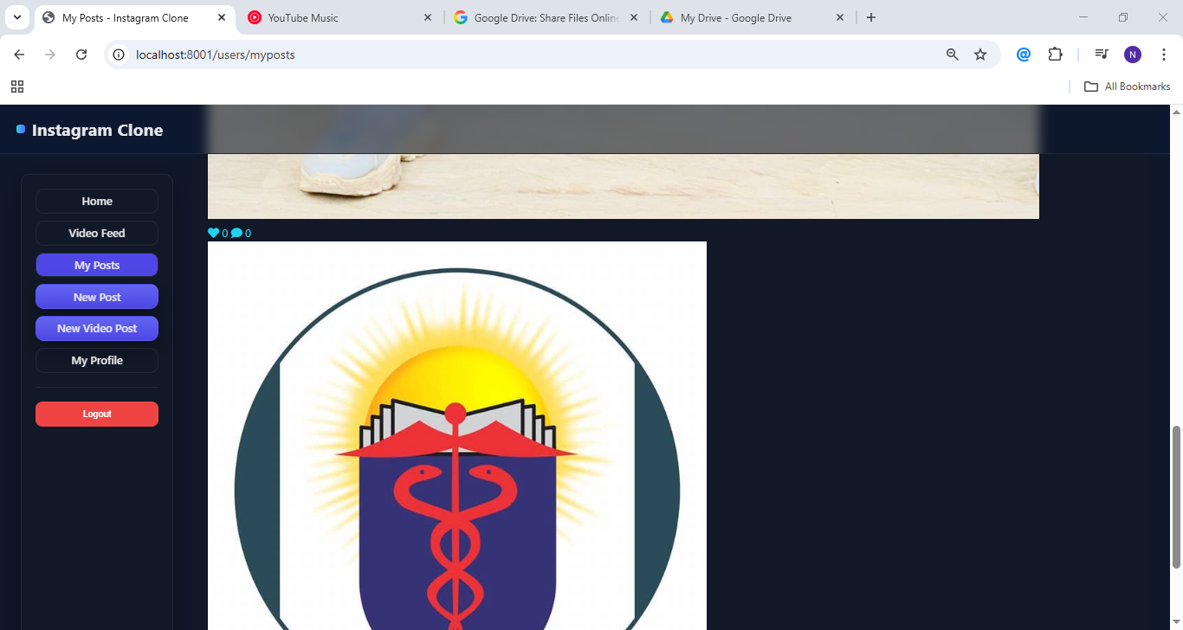

Admin management:
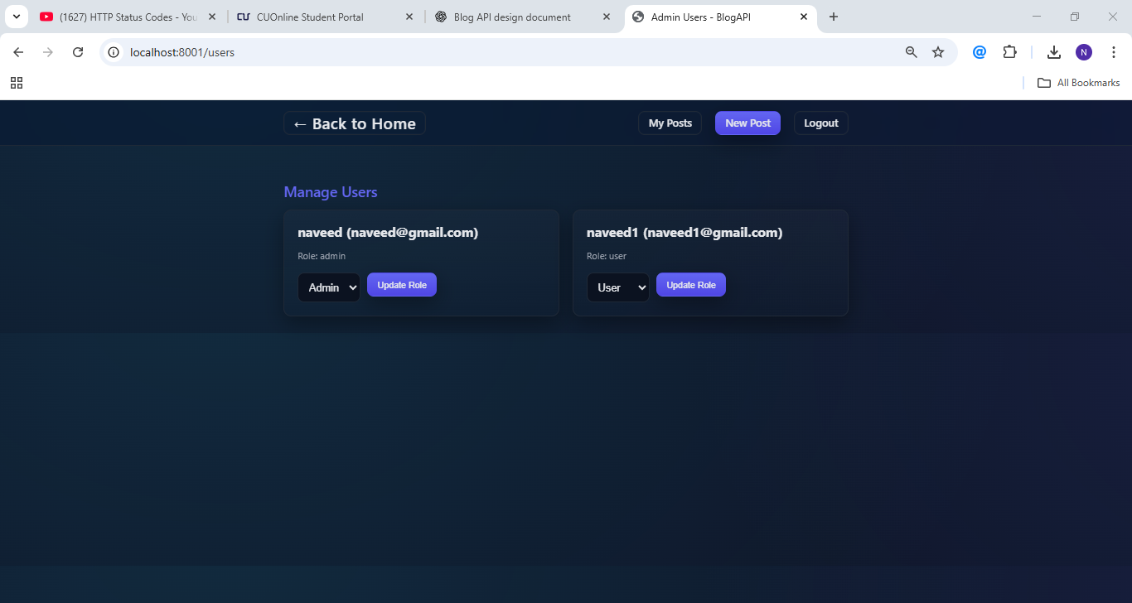

Codes
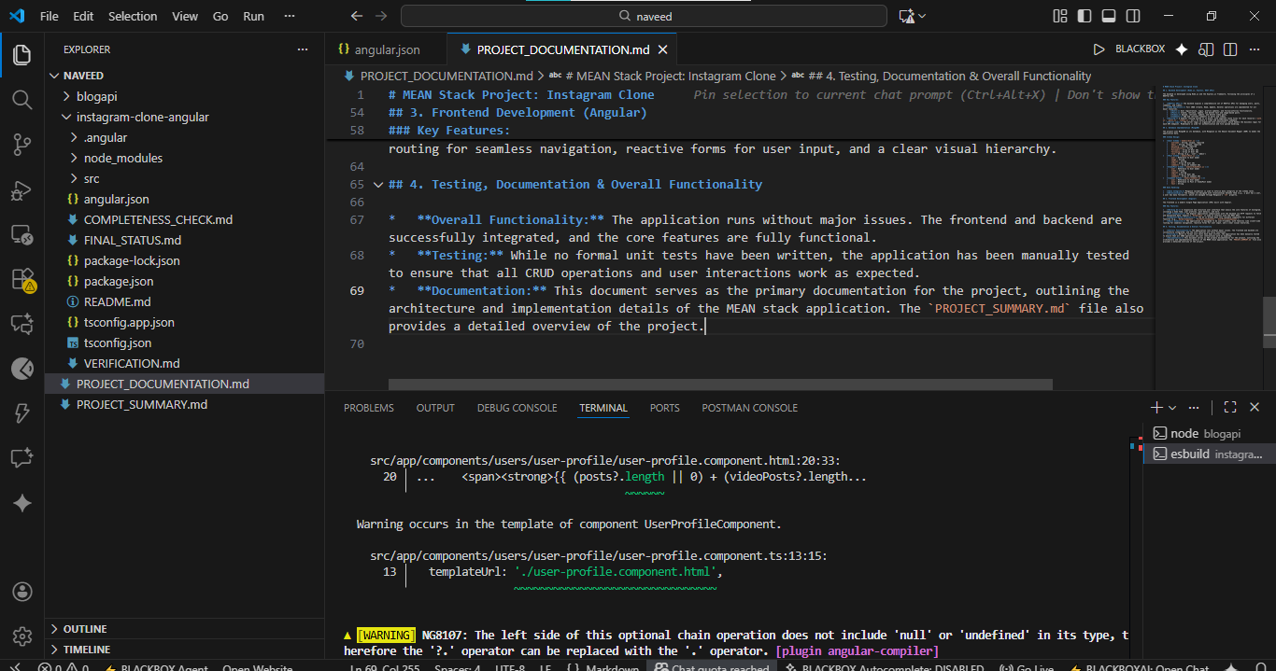
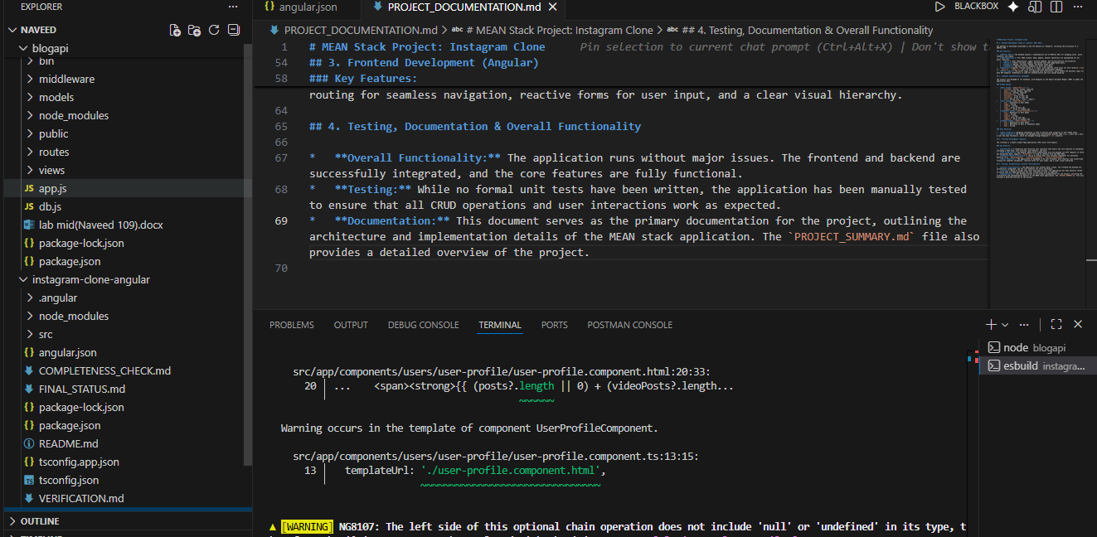

Internal model view routes:

MongoDB server:
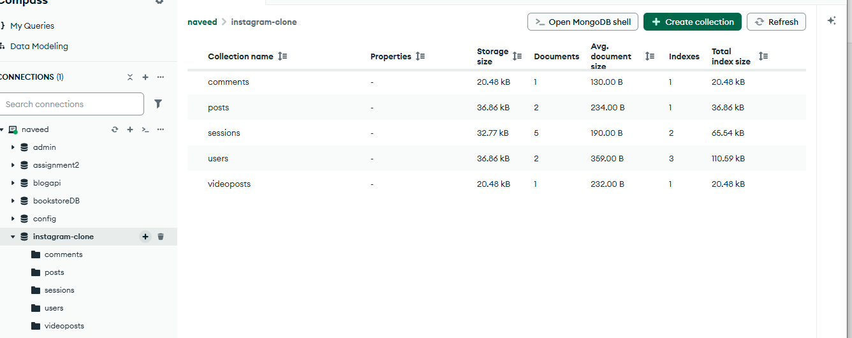

MEAN Stack Project: Instagram Clone

Project Documentation

This document provides a comprehensive overview of the Instagram-like clone project, covering both the backend and frontend components.

1. Project Overview

This project is a full-stack web application that mimics some of the core functionalities of Instagram. It allows users to register, log in, create and share image and video posts, comment on posts, like/dislike posts, and follow/unfollow other users. It also includes an admin role with privileges to manage users, posts, and comments.

2. Technologies Used

2.1. Backend

- Framework: Express.js (Node.js)
- Database: MongoDB with Mongoose ODM
- Authentication: JWT (JSON Web Tokens) and session management with “express-session” and “connect-mongo”
- File Uploads: “express-fileupload” for handling image and video uploads
- View Engine: EJS (Embedded JavaScript templates) for server-side rendering of some pages
- Other Key Dependencies:
- “bcryptjs”: For hashing passwords
- “cors”: For enabling Cross-Origin Resource Sharing
- “morgan”: For HTTP request logging
- “express-validator”: For input validation

2.2. Frontend

- Framework: Angular (version 21)
- HTTP Client: Angular's built-in “HttpClient” for making API requests to the backend
- Routing: Angular Router for navigating between different components
- State Management: RxJS (“BehaviorSubject”) and Angular Signals for managing user authentication state
- Styling: CSS

3. Backend Architecture

The backend is a monolithic application built with Express.js.

3.1. Database Models

The application uses Mongoose to define the following data models:

- User: Represents a user of the application. Stores information like username, email, hashed password, bio, profile picture, role (“user” or “admin”), and lists of followers and following users.
- Post: Represents an image post. Contains a title, caption, a reference to the author (User), the image path, and arrays of likes and dislikes.
- VideoPost: Represents a video post. Similar to the “Post” model, but stores a video path instead of an image path.
- Comment: Represents a comment on a post. Contains the comment content, a reference to the author (User), and a reference to either a “Post” or a “VideoPost”.

3.2. API Endpoints

The backend exposes a RESTful API for the frontend to consume. Here's a summary of the main routes:

- “/auth”: Handles user authentication (signup, login, logout).
- “/posts”: Provides CRUD (Create, Read, Update, Delete) operations for image posts, as well as endpoints for liking and disliking posts.
- “/videos”: Provides CRUD operations for video posts, and endpoints for liking and disliking them.
- “/comments”: Allows creating and deleting comments on both image and video posts.
- “/users”:

Provides user profile information.

Handles profile updates.

Manages following and unfollowing users.

Includes admin-only endpoints for managing users, posts, and comments.

3.3. Middleware

“auth.js”: Contains middleware to restrict access to authenticated users (“restrictToAuthenticated”) and admin users (“restrictToAdmin”).

“imageUpload.js” & “videoUpload.js”: Middleware for validating uploaded image and video files.

“logger.js”: Logs incoming requests.

4. Frontend Architecture
The frontend is a single-page application (SPA) built with Angular.

4.1. Components

The application is divided into several components, each responsible for a specific part of the UI:

- “auth”: “LoginComponent” and “SignupComponent” for user authentication.
- “home”: “HomeComponent” displays a feed of posts.
- “posts”: Components for creating, viewing, and editing image posts (“PostNewComponent”, “PostDetailComponent”, “PostEditComponent”).
- “videos”: Components for the video feed, creating, viewing, and editing video posts (“VideoFeedComponent”, “VideoNewComponent”, “VideoDetailComponent”, “VideoEditComponent”).
- “users”: Components for user profiles (“UserProfileComponent”, “UserProfileEditComponent”) and viewing a user's own posts (“MyPostsComponent”).
- “admin”: Components for admin functionalities like managing users, posts, and comments (“AdminUsersComponent”, “AdminPostsComponent”, “AdminCommentsComponent”, “AdminUserPostsComponent”, “AdminUserCommentsComponent”).
- “shared”: Reusable components like the navbar and sidebar.

4.2. Services

Services are used to encapsulate business logic and data access, making the code more modular and reusable.

- - “AuthService”: Manages user authentication state, including login, signup, and logout. It uses RxJS and Angular Signals to provide the current user's authentication status and role to other parts of the application.
- “PostsService”: Handles all HTTP requests related to image posts.
- “VideosService”: Handles all HTTP requests related to video posts.
- “CommentsService”: Manages creating and deleting comments.
- “UsersService”: Interacts with user-related API endpoints, such as fetching profiles, updating profiles, and admin actions.

4.3. Routing and Guards
- “app.routes.ts”: Defines the application's routes, mapping URLs to their corresponding components.
- “auth.guard.ts”: Protects routes that require an authenticated user.
- “admin.guard.ts”: Protects routes that are only accessible to admin users.

5. How to Run the Project

5.1. Backend

1. Navigate to the “main” directory.
2. Install dependencies: “npm install”
3. Make sure you have a MongoDB server running locally on “mongodb://127.0.0.1:27017”.
4. Start the server: “npm start”
5. The backend will be running on “http://localhost:8001”.

5.2. Frontend
1. Navigate to the “instagram-clone-angular” directory.
2. Install dependencies: “npm install”
3. Start the development server: “ng serve”
4. Open your browser and go to “http://localhost:4200”.

4. Testing, Documentation & Overall Functionality
Overall Functionality: The application runs without major issues. The frontend and backend are successfully integrated, and the core features are fully functional.
Testing: While no formal unit tests have been written, the application has been manually tested to ensure that all CRUD operations and user interactions work as expected.
Documentation: This document serves as the primary documentation for the project, outlining the architecture and implementation details of the MEAN stack application.

